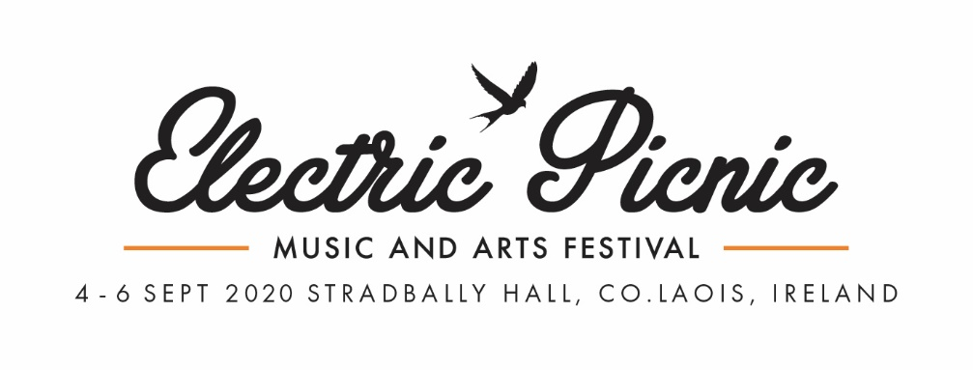

FIELD STUDIES 2020 - APPLICATION FORM
- Field Studies is open to all IADT students.
- The application deadline is the 21st of February.
- The first round of interviews will be held on the 26th & 28th of February, one week’s notice will be given if you have been called to interview.
- If you are applying as a group note the names of the members and fill out one form.

- Personal Details
NAME
STUDENT NUMBER
EMAIL
COURSE
HAVE YOU ATTENDED ELECTRIC PICNIC BEFORE?
If so what year/s?
HAVE YOU DISPLAYED WORK OR PERFORMED AT ELECTRIC PICNIC BEFORE?
If so give details.

- Art Installation Details

- Electric Picnic is an outdoor festival in Ireland and can get every type of weather in one hour.
- Installations can be standalone pieces or incorporated into the trees and foliage onsite.
TITLE OF INSTALLATION
DESCRIPTION OF INSTALLATION
Inspiration, Materials, Colours, Size, Build Process, Displaying location etc

Max 500 words.
SCALE DRAWINGS, MODELS, SAMPLES & INSPIRATION | Please attach any supporting documents as a PDF with your application email.  Name File: EP_2020_FieldStudies_Vis_(NAME)_

- Installation Details

- If accepted into ‘Field Studies’, you must build and complete your installation in your own time off site or during college time between March to May.
- Installation slots will be allocated between the 3rd to 31st of August.
- The site is open for work from 8am to 8pm.

ESTIMATED BUILD TIME

ESTIMATED INSTALLATION TIME ONSITE
e.g. half day, full day, two days.
EQUIPMENT / INFRASTRUCTURE NEEDED
e.g. ladder, cherry picker, electricity.

DESCRIPTION OF THE INSTALLATION PROCESS
Build stages when onsite

WILL YOU BRING SOMEONE TO HELP YOU INSTALL?

- Additional Information
Any additional notes or information you wish to share.

Please send your application form and supporting materials as a PDF to;
ep.arts@festivalrepublic.com
The subject line of the email must read;
IADT & EP 2020 – Field Studies Application (Insert Name)
The application deadline is the 21st of February 2020, please read the T&Cs linked on the website.
If you are called for interview you will be given one week’s notice, interviews will be conducted on the 26th and 28th of February in IADT. Please note you will need to bring all supporting materials, visual aids and scale drawings/models to this interview.
If accepted into ‘Field Studies’, you will be notified on the 2nd of March. All successful applicants will receive a full weekend camping ticket for themselves and a friend.

Thank you for your application and the best of luck.

Kind Regards,
Electric Picnic Arts Team
