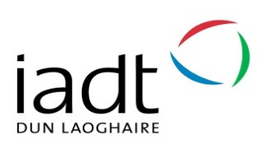
WHEN CAN AN IADT STUDENT GO OUT ON ERASMUS?
Programme | Year | Term (1, 2 or full academic year)
DL821 - English, Media and Cultural Studies | 2 | Term 2
DL822 – Arts Management | 3 | Term 2
DL823 - Entrepreneurship and Management | 3 | Term 2
DL826 - Visual Communication Design | 2 and 3 | Term 1 or Term 2 in both years  Ideally: Year 2, T1 for studies; Yr 3 for placements
DL827 - Art | 2  3 | Term 2  Term 1, Term 2 or Full Academic Year
DL828 – 3D Design, Modelmaking and Digital Art | 3 | Term 2
DL829/DL830/DL831 - Design for Stage and Screen | 3 | Term 1
DL832 - Animation | 3 | Term 1, Term 2 or Full Academic Year in both years
DL833 - Photography | 2  3 | Full Academic Year only  Term 1, term 2 or Full Academic Year
DL834 - Film and Television Production  (Full year option in Year 2 to be considered by student with programme co-ordinator) | 2  3 | Term 1, term 2 or Full Academic Year  Term 1
DL836 - Creative Computing | 2 | Full Academic Year
DL835 - Creative Media Technologies | 2 | Full Academic Year
DL837 – New Media Studies | 2 | Term 2
DL907 – MA in Art and Research Collaboration | 2 | Term 1

