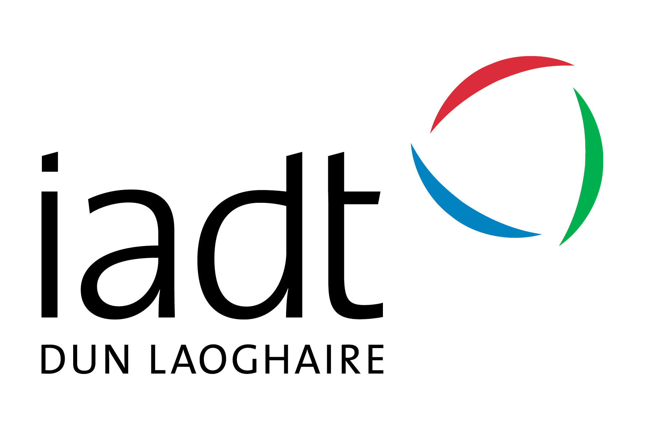 Job Descriptor

FYM Student Leaders

Urgently Required:

Student Leaders/Facilitators for IADT First Year Matters (FYM) Extended Orientation Programme: ‘First Four Weeks’

Applications due: (via Google form or by video CV emailed to FYM@iadt.ie by Friday, 13th March 2020 at end of day (11.59 pm).
Applicants should be available for interview (in person or via Skype): the week of the 23rd March 2020
IADT is continuing the enhanced orientation programme for our incoming first year students as part of the First Year Matters (FYM) programme. We are looking for a number of individuals to liaise with the incoming first years over a number of weeks in September in a part-time capacity.

We especially encourage new applicants and mature students to apply.
Reporting to: | Denise McMorrow, Leah de Lacey, Sinead McEntee and Various Stakeholders (Student Services, Academic Services, Student Union, First Year Task-Force, First Year Tutors)

Responsibilities  General | FYM Student Leaders will be part of the creative team and will have a number of responsibilities over the programme, including:  - Organising and implementing a number of events over the First Four Weeks with the Students’ Union and FYM team.  - Welcoming and directing incoming students during registration and induction.  - Supporting SU, Management, Lecturers, Staff and Student Services during the extended orientation programme.  - Informing incoming first year students and other direct entry students about the events over the week(s).  - Directing students to the proper services available on campus to help them sort out issues they may be encountering regarding transition into third level education.  - Creating a ‘buzz’ and positive engagement ‘vibe’ across the Institution amongst students and staff by actively engaging in the events and encouraging others to participate.  Leader roles will be delegated based upon student’s skills and interests
Ideal Candidate Attributes | - FYM Student Leaders must be currently registered as full time students in IADT.  (i.e. have been fully registered in 2019/2020 and be eligible to go into 2020/2021)  - Have evidence-based interest as well as experience in the following:  - The Institute and in our diverse student body.  - Be familiar with the IADT Learners Charter, and other student policies (available on http://www.iadt.ie/about/policies-procedures/student-policies).  - Be hardworking and willing to ‘muck in’ to do anything from filling ‘goodie bags’ to actively attending events and cleaning up.  - Strong team member and work well in a close-knit group.  - Be outgoing and friendly with a real interest in other people.  - Be organized and have the ability to get the job done in terms of planning and implementing successful events for large groups of people.  - Good communication skills with the potential to speak in front of people  - Encourage and inspire confidence and feelings of well-being in others.  - Remember what it was like to be a first year and be interested in supporting and leading others in a team.  In addition, ideal candidates will be able to:  - Demonstrate strong people skills in interview and have evidence of previous experience similar to what is expected from the FYM leaders.  - Demonstrate attributes and prior skills as needed for the specific role(s) sought (Leader, Communications and/or Administrative Officer).  - Be willing to be ‘an Ambassador’ for the Institute and an example to First Year Students.
How Many Hours? | The positions are Monday to Friday and hours each day will vary from week to week depending on the events schedule:  You will be expected to participate in 1-2 training day(s) dates TBC. 1 training day in May 2020 and I training day August 2020.  Leaders must be available the week prior to FYM for training and preparation  30 hours during week 1 - Induction week in September,  20 hours during the subsequent weeks (Week 2-4 in September)  This is a part time position and will NOT interfere with your own classes or weekends (Saturdays and Sundays). Hours of work will be scheduled from 8.30 am to 10.00 pm during the First Four Weeks during the different morning, lunchtime and evening first year student events. The programme finishes on Friday, the 4th of October.
If Successful, What Will I Get Paid? | Successful candidates will receive payment of €500.00 before tax and other state deductions, as applicable.
How Do I Apply? | Application Process  Please fill out the application form online by end of day, March 13th 2019
Questions? | Please email FYM@iadt.ie if you have further questions.

Don’t Delay – Apply today

