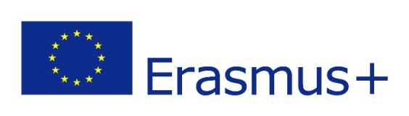
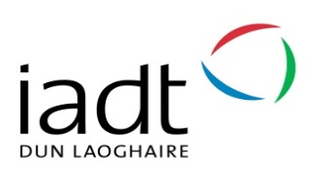
WHEN CAN AN IADT STUDENT GO ABROAD ON ERASMUS?
Programme | Year | Term (1, 2 or full academic year)
DL701 - Applied Entrepreneurship | 2 | Term 2
DL821 - English, Media + Cultural Studies | 2 | Term 2
DL822 - Arts Management | 3 | Term 2
DL823 - Entrepreneurship + Management | 3 | Term 2
DL826 - Visual Communication Design | 2 and 3 | Term 1 or Term 2 in both years  Ideally: Year 2, T1 for studies; Yr 3 for placements
DL827 - Art | 2  3 | Term 2  Term 1, Term 2 or Full Academic Year
DL828 - 3D Design, Modelmaking + Digital Art | 3 | Term 2
DL829/DL830/DL831 - Design for Stage + Screen | 3 | Term 1
DL832 - Animation | 3 | Term 1, Term 2 or Full Academic Year
DL833 - Photography | 3 | Term 1, Term 2 or Full Academic Year
DL834 - Film + Television Production | 2  3 | Term 1, Term 2 or Full Academic Year  Term 1
DL836 - Creative Computing | 3 | Term 2
DL837 - New Media Studies | 3 | Term 2
DL838 - Creative Music Production | 2 | Term 1, Term 2 or Full Academic Year
DL840 - Digital Marketing | 2 | Term 2

