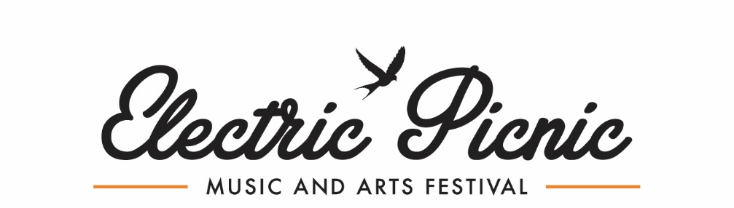

GENERATE: CONNECTION

GENERATE is a new project for 2023 between IADT and Electric Picnic, whereby we invite students to apply as an individual or group to present an original piece of their work at the festival held in Stradbally, 1-3rd September 2023. This year we want to explore the theme CONNECTION, which can be interpreted how applicants choose. Applications are open to all students working across both 2D (eg. photo/print) and 3D (eg. sculpture) mediums.
Successful works will be presented in an IADT “gallery” at the festival. Grants of up to a maximum of €200 will be available to successful applicants, to create their proposed work for the festival. Each successful applicant will receive 2 x weekend passes to the festival, which will be issued following the work’s installation on site.
This is a competitive process with a limited number of spaces. Applications will be reviewed by a panel constituting both IADT and EP representatives, with a number of selected applicants being invited to interview. Successful applicants will be notified by no later than 8th May 2023 following the interview process. All pieces must be completed and stored at IADT by 30th June.
Key things to think about in your application
- Criteria- 2D work should be 2m X 1m | 3D work no greater than 1m X 1m
  - 2D work will be mounted on standalone billboards
  - 3D work can be ground mounted or hanging (off a tree)
- Practicality – think about materials / size and durability – the piece needs to survive a weekend long outdoor festival with varying weather
- Timing – be realistic about what you can create within the time frame. All pieces must be completed and stored at IADT by 30th June.
- Resources– you will be able to access IADT equipment within term time only. Out with term time you will have to use your own resources.
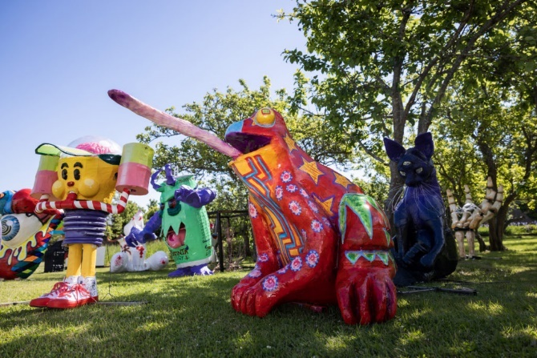
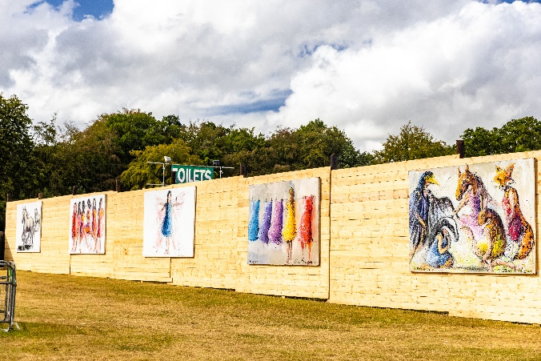
- Theme – think creatively and outside the box
Example of 3D piece by IADT students at EP 2022. Example of 2D piece mounted on billboard at EP 2022.
Artist: IADT students Artist: Clare Hartigan

APPLICATION FORM
- The application deadline is 10am, 17th April 2023. Interviews will occur between 1st – 5th May in IADT or over zoom. Successful applicants will be notified by no later than 8th May 2023.
- Successful pieces must be complete and stored in IADT by 30th June 2023.

- Personal Details
NAME
STUDENT NUMBER
EMAIL
COURSE
HAVE YOU ATTENDED ELECTRIC PICNIC BEFORE?
If so what year/s?
HAVE YOU DISPLAYED WORK OR PERFORMED AT ELECTRIC PICNIC BEFORE?
If so give details.

- Art Installation Details
- Electric Picnic is an outdoor festival in Ireland and can get every type of weather in one hour.
- Installations can be standalone sculptural pieces, or prints / paintings etc. that will be mounted and displayed on boards.
- Installations will be transported and placed on-site by IADT and the EP Arts Team prior to the festival weekend.

TITLE OF INSTALLATION
DESCRIPTION OF INSTALLATION
Inspiration, Materials, Colours, Size, Build Process etc.

Max 500 words.
HOW WILL THE WORK BE PRESENTED?
Eg. Mounted on board / on stake in ground

- Budget
- Grants of up to a maximum of €200 are available to cover installation materials / resources, which will be reimbursed with receipt submission following your work’s completion and drop-off to IADT by 30th June 2023
- Please note if successful – all receipts must be kept and submitted to receive reimbursement
PLEASE DETAIL YOUR INSTALLATION BUDGET:
(max. €200)

If exact figures are not known, please give estimated figures

- Additional Information
ANY ADDITIONAL NOTES OR INFORMATION YOU WISH TO SHARE.
PLEASE ATTACH ANY SUPPORTING DOCUMENTS AS A PDF WITH YOUR APPLICATION EMAIL WITH YOUR NAME + INSTALLATION NAME AS THE TITLE.
Please send your completed application form and supporting materials as a PDF by 10am, 17th April 2023 to: ep.arts@festivalrepublic.com
The subject line of the email must read;
IADT & EP 2023 – GENERATE Application (Insert Name)
The application deadline is 10am, 17th April 2023. Applications received after this deadline will not be considered. Please read the T&Cs linked on the website.

If you are called for an interview you will be given one week’s notice. Interviews will be conducted between 1st and 5th May in IADT or over zoom. Please note you will need to bring all supporting materials, visual aids and scale drawings/models to this interview.

If accepted into GENERATE, you will be notified by no later than 8th May. Successful pieces must be complete and stored in IADT by 30th June 2023.

All successful applicants will be reimbursed for their material costs up to a maximum of €200 and receive a full weekend camping ticket for themselves and a friend, distributed on-site once the completed work has been installed.

Thank you for your application and the best of luck.

Kind Regards,
Electric Picnic Arts Team

