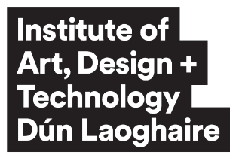 |  | Programme Board Annual Report  to Academic Council
Academic Session
Programme Code |  | DL
Programme Name
Programme Stages |  | Year 1 Year 2 Year 3 Year 4 Year 6
Date of Report
- Overall Report
1.1 Overview
1.2 Key Accomplishments
1.3 Student Achievements
- Student Performance
2.1 Examination Results*
2.2 Progression and retention figures**
*Examination results data to include the total number of students & number of students who successfully completed year.
**Progression & retention figures to include figures for 1st to 2nd year and figures for completion year
- Student Feedback
- Programme Overview
4.1 Details of any changes to the programme
- External Examiners
5.1 Recommendations
5.2 Response to Recommendations
- Priorities for the next Academic Year (including Actions)
- Areas for Improvement

Head of Department Signature
Student Representative Signature

Please return completed and signed reports to the Senior Quality Officer: quality@iadt.ie

